
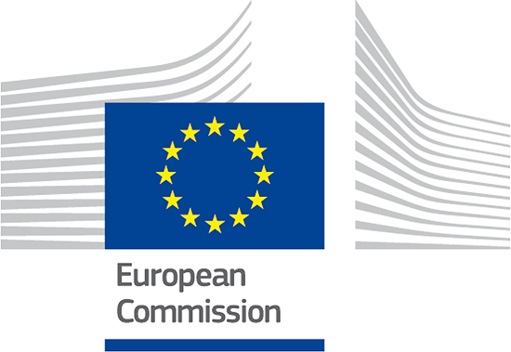
Welcome to
Euroweek School of Leaders!

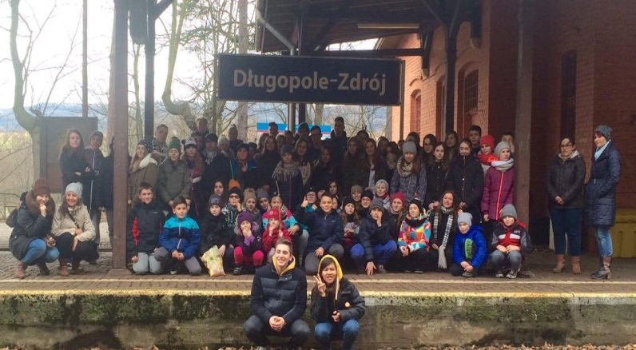
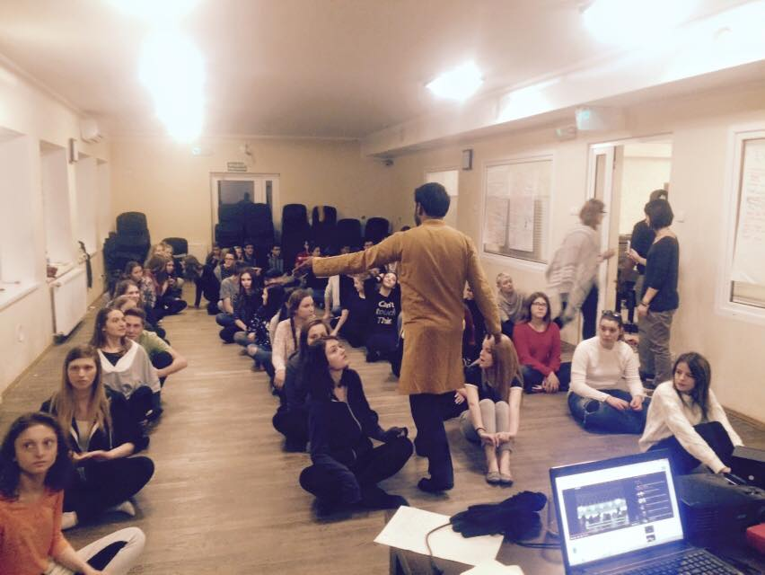

PROJECT INTRODUCTION

EUROWEEK is a seven day non-formal education and cultural program. It is happening simultaneously in three hotels, Silesia, Alexander and Slconezna in Bystryzca Klodzka, Poland.
The program is being facilitated by Youth Leaders (Volunteers) coming from different countries around the world. To date, we have volunteers from Africa, Asia, North and South America and Europe. The program focuses on four key areas that the students need most especially in this fast changing environment; cross-cultural, social and communication, intellectual and creativity skills.
The world is a global village today, it is therefore important for the students to be more equipped on different cross-cultural issues of the world. Euroweek brings international volunteers who can help the students broaden their perspective about cultural differences and harness their skills for international collaboration. To make this happen, volunteers provide them with information about their history, economy, tourism, culture, people, and traditions in the most interactive and personal ways that the students can remember and understand it easily.
To improve the social and communication skills of the students, Euroweek provides an open space to develop their self-confidence by using different team building games, and workshops such as language, listening, role playing, presentation techniques, motivational talks and group discussion with the volunteers.
Furthermore, to enhance the intellectual and creativity skills of the students, the program also provides them with different workshops and activities such as problem solving, leadership, creativity, project management, debates, refugee workshops, stereotyping, comparing topics and others. After these activities the students are expected to be more critical and open- minded in analysing information.

Volunteers
Euroweek is also a learning space for volunteers. The volunteers can create; teach workshops and other activities that would not only benefit the students but also contribute to their growth as individuals, team players and leaders.
Duties and Responsibilities of Youth Leader (Volunteer)
- The volunteer should prepare and present the best his/her country can offer. He/she can also include dance, music, arts, language, and show off the traditional dress and others that will make the presentation lively and interactive.
- He/ she should also present and do different team building activities and workshops with the students.
- He/she is highly encouraged to share and develop new team building games and workshops for the students.
- As part of the learning process, volunteer should make a Learning Report every month to be submitted, reported and filed for future references.
- He/she will lead and facilitate the activities together with other leaders.
- Over- all the volunteer should actively participate in all meetings, workshops, activities with full and positive energy all the time.

Qualifications
- 19- 30 years old.
- Studying and/or graduated from college.
- The volunteer should be available until the full duration of the program.
- Good command in English.
- Has experience in handling small and big groups of primary, secondary and high school students.
- Can adapt easily in the changing norms, lifestyle and environment in workplace and in volunteer’s habitat.
- Can adjust to various personality types.
- Creative and flexible, problem solver, open-minded, outspoken communicator, smart and confident strategists.
- Take initiative, think and work fast, have an eye for detail and welcome collaboration.
- Can participate in ALL activities in Euroweek as per the intended schedule.

Administrative and Logistics
- The organization is responsible in assisting the volunteer in the provision of documents that might be required for the visa application process.
- Any transport in connection with the project will be covered by the host organization. If the volunteer has to go to his/her work place or to his language course, those costs will be refunded after the submission of the transport tickets by the volunteer.
- The volunteer will live on the country side in volunteers’ house and will share the room with other volunteers in Dlugopole Gorne, Poland. (See table 1 below for further illustration)
- During the Euroweek activities, volunteer has free food (Polish standard) in the hotel.
- The organization understands the need of the volunteer to communicate better with her/his participants, thus, the volunteer will undergo a weekly Polish Lesson that the organization will provide to enable effective communication.
- The volunteer is entitled to have a two-day break per week or 8 days free time in a month.
Allowance and other Expenses
- The volunteer will not pay anything in the organization, however, he/she is responsible in purchasing his/her own visa, insurance, flight ticket back and forth, and local transportation fee from his/her country to the nearest train station in Dlugopole Gorne, Poland.
- The volunteer will receive monthly allowance for food amounting 360 ZL and another 360 ZL for pocket money. (See table 1 below for further illustration)

Table 1
Items | Host Organization  EFM- Euroweek Program | Volunteer
Travel Cost  (e.g. flight, domestic transportation) | ------------------ | Covered by Volunteer
Insurance Cost | ------------------ | Covered by Volunteer
Accommodation | Covered by the Hosting Organization | ------------------
Volunteer’s Allowance  (Total- 720 zl) | Covered by the Hosting Organization  360 zl- food  360 zl- pocket money | ------------------
Local Transportation (Poland) | Covered by the Hosting Organization | ------------------
Language Support | Covered by the Hosting Organization | ------------------
Visa Cost |  | Covered by Volunteer

- ***The volunteer is expected to leave the house going to his/her hotel on or before 9:00 am in the morning and stay until the last activity- disco is finished, which is around 10 pm. (See example activity schedule below)

SAMPLE DAILY ACTIVITIES

Day 1

1 pm- 6pm- Arrival of Participants
5:30 pm- 6:30 pm- DINNER
7:00 pm- 8:00 pm- Welcoming and Introduction of Volunteers/ Games
8:00 pm- 10:00 pm- Welcoming Party

Day 2

8:30 am- 9:30 am- Breakfast (Polish Food)
9:30 am-10:00 am- Energizer
10:00am - 10:30 am- Expectation
10:30am- 10:45 am- Break
10:45am- 11:45 am- Workshop 1
11:45 am- 12:00 noon- Break
12:00 noon- 2:00 pm- Walking
2:00 pm- 3:00 pm- LUNCH
3:00 pm- 4:00 pm- Karaoke/ Team Building Games
4:00 pm- 4:15 pm- Break
4:15 pm- 5:00 pm- Group Discussion
5:00 pm- 5:15 pm- Break
5:15 pm- 6:00 pm- Workshop 2
6:00 pm- 7:00 pm- DINNER
7:00 pm- 8:00 pm- Country Presentation
8:00 pm- 10:00 pm- Disco

Day 3
TOUR- PRAGUE/ VIENNA/ WARSAW (Full Day) or LOCAL TOUR

**Half day for Local Tour in Bystryzca and Klodzko Poland

2:00 pm- 3:00pm- LUNCH
3:00 pm- 4:00 pm- Country Presentation
4:00 pm- 4:15 pm- Break
4:15 pm- 6:00 pm- Talent Show
6:00 pm- 7:00 pm- DINNER
7:00 pm- 8:00 pm- Workshop 3
8:00 pm- 9:00 pm- Traditional Dance/ Disco

Day 4

8:30 am- 9:30 am- Breakfast (Polish Food)
9:30 am-10:00 am- Energizer
10:00am - 10:45 am- Workshop 4
10:45am - 11:00 am- Break
11:00 am- 12:00 noon- Team Building Games
12:00 noon- 12:30 pm- Break
12:30 pm-1:30 pm- Country Presentation
1:30pm -2:00 pm- Break
2:00 pm- 3:00 pm- LUNCH
3:00 pm- 4:00 pm- Team Building Games
4:00 pm- 4:15 pm- Break
4:15 pm- 6:00 pm- Workshop 5
6:00 pm- 7:00 pm- DINNER
7:00 pm- 8:00 pm- Country Presentation

Day 5

8:30 am- 9:30 am- Breakfast (Polish Food)
9:30 am-10:00 am- Energizer
10:00 am- 11:00 am- Workshop 6
11:00 am-11:15 am- Break
11:15 am- 2:00 pm- Walking in the mountain
2:00 pm- 3:00 pm- LUNCH
3:00 pm- 4:00 pm- Team Building Games
4:00 pm- 4:15 pm- Break
4:15 pm- 5:00 pm- Workshop 7
5:00 pm- 5:15 pm- Break
5:15 pm- 6:00 pm- Traditional Dance 1
6:00 pm- 7:00 pm- DINNER
7:00 pm- 8:00 pm- Country Presentation
8:00 pm- 10:00 pm- Disco

Day 6
8:30 am- 9:30 am- Breakfast (Polish Food)
9:30 am-10:00 am- Energizer
10:00am- 11:30 am- Workshop 8
11:30am- 12:00 noon- Break
12:00 noon-1:00 pm- Team Building Game
1:00 pm- 1:15 pm- Break
1:15 pm- 2:00 pm- Country Presentation
2:00 pm- 3:00pm- LUNCH
3:00 pm- 4:00 pm- Workshop 9
4:00 pm- 4:15 pm- Break
4:15 pm- 5:00 pm- Traditional Dance 2
6:00 pm- 7:00 pm- DINNER
7:00 pm- 8:00 pm- Country Presentation
8:00 pm- 10pm- Disco Polo

Day 7

8:30 am- 9:30 am- Breakfast (Polish Food)
9:30 am-10:00 am- Energizer
10:00 am- 11:00 am- Workshop 11
11:00 am-11:15 am- Break
11:15 am- 2:00 pm- Walking in the mountain
2:00 pm- 3:00pm- LUNCH
3:00 pm- 4:00 pm- Country Presentation
4:00 pm- 6:00 pm- Mission Impossible
6:00 pm- 7:00 pm- DINNER
7:00 pm- 8:00 pm- Workshop 1
8:00 pm- 9:00 pm- Closing and Evaluation
9:00 pm- 10:00 pm- Farewell Disco

Day 8
Departure of the Participants

Contact Information
- For interested applicant please send your CV/ Resume and Motivation Letter at:
E mail add: adameuroweek@gmail.com
Skype: adam.jasnikowski
Facebook https://www.facebook.com/adam.jasnikowski
- For more information about Euroweek visit us
www.facebook.euroweekofficialpage.com

Adam Jasnikowski
Director Euroweek School of Leaders

