4/9/2013 | Price: Priceless!!!


Tuesday/ponedeljek/teisipäev/terça-feira/otrdiena/Triti, 3rd September 2013

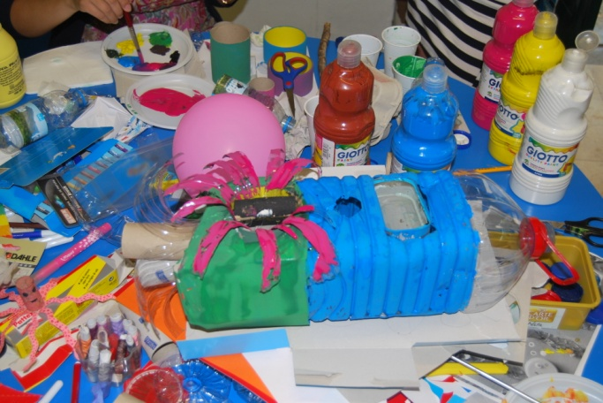
My morning was good, because I didn’t party last night and because of all alarm clocks (which are mostly popular songs) which wake me up every morning. I eat the same food every morning. At first I take bread, butter, honey, coffee and cacao, and than one bread with salami and cheese. It was the Estonian days, so they prepared for us games for all day. We had workshop day, which means we were doing art with trash. But I am in Media group so I do art with articles. After my job I went with friends to Lidl to buy some chocolate and icecream. Then we went sightseeing, I bought postcards, took some photos and drink coctails. After dinner Estonians presented their culture, habits, national songs, food and drinks. It was a nice evening. We went out to have fun, as we are party animals, but unfortunately we didn’t have much time to dance. Some of us were playing games after we came home and then went to bed. I can not wait until the surfing day.

Written by Anja (Slovenia)

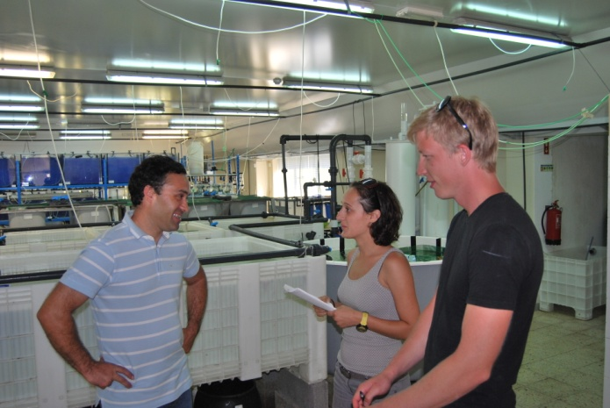
Day at the School of Tourism and Maritime Technology
Peniche University is a public institution of Higher Education. They are studying and researching different ocean bacterias, fishes, etc. First they showed us introducing video about one island called Berlenga. They are diving a lot near to Berlenga island, because there is very fascinating barrier reef with all these fishes and starfishes. After that video we all went to the research lab where we were talking about different subjects, such as fisheries, artificial aquariums, genetics etc. There was a lot of aquariums. In these aquariums they are growing fishes and bacterias. Rooms were also very smelly, like fishes were everywhere, but it's okey, I like fishes. Teacher was talking a lot so you could ask him anything.
Written by Madis (Estonia)
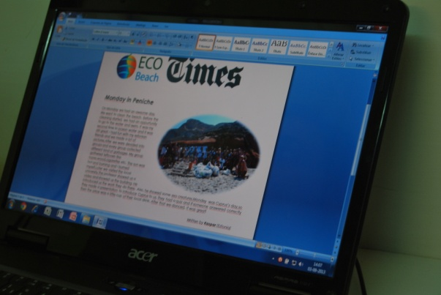
exCHANGE – Work hard or go home.
Before the youth exchange started, I was thinking only about few things:
- Try to surf
- Meet new friends
- Learn something about other countries and culture
- Have some parties
But now my opinion is changed, I was joined MEDIA team and at first our work day we had a lot of job, and we didn’t mess up…
I’m getting new and great information and experience for myself, IT’S REALLY GOOD FOR ME!!!
Writted by Jevgenijs (Latvia)
Ladies and Gentleman ... We present you Portugal
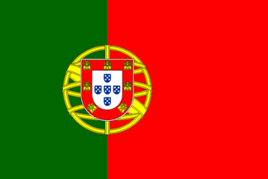
Portuguese people accept foreign people.
They are quite comprehensive and always try to speak in a language that everybody understands.
A good thing about Portuguese people is that they always try to provide the country and the culture best possible, being very communicative and helping you to speak portuguese, so if you try you will see that it is not that difficult to learn the language or the culture.
Portugal is visited by thousands of people every year, being that, Portuguese people have the skill to learn practice and not judge different cultures.
If you are thinking about visiting Portugal, don’t think twice – you are more than welcome!
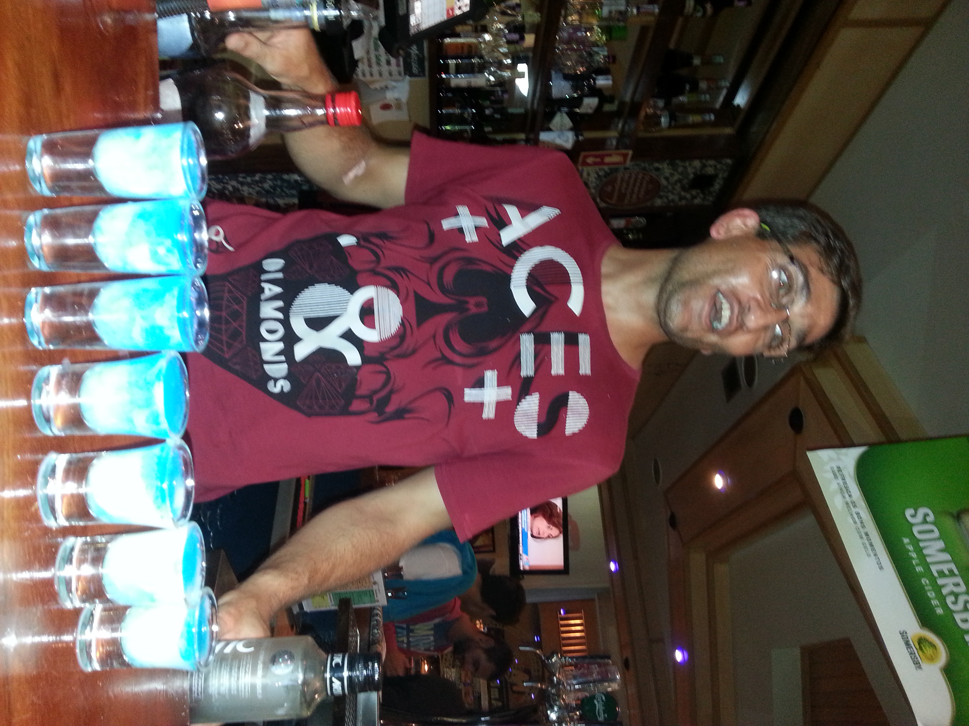Written by Joao (Portugal)
Having fun in Peniche
This is the 5th day in Peniche and we already have enjoyed parties in this place.
Every night has been full of adventures and happiness.
People in Peniche who we met at the parties are so nice and welcoming. We really enjoyed the “Java House” an “Ambassador”.
At a second night in Peniche we went there for the first time, we danced a lot and had a great time. It’s interesting that it’s not necessary to go outside to smoke, we can do it inside. In Latvia it’s not allowed.
We were really glad to have barman in “Java House” speaking Latvian with us at the first night. He was speaking some words in Estonian in Slovenian languages too. It’s nice that every barman speaks English very well. We think that the best drink here is “Sangria” and it’s cheap too.
We hope that other nights in Peniche will be that great too and we all can have a great time together.

Written by Anna and Rasa (Latvia)
Lets learn some languages…
English | Portugal | Cyprus | Estonia | Slovenia | Latvia
Zero | Zero | Miden | Null | Nič | Nulle
One | Um | Ena | Üks | Ena | Viens
Two | Dois | Duo | Kaks | Dve | Divi
Three | Tres | Tria | Kolm | Tri | Tris
Four | Quatro | Tessera | Neli | Štiri | Cetri
Five | Cinco | Pente | Viis | Pet | Pieci
Six | Seis | Exi | Kuus | Šest | Sesi
Seven | Sete | Efta | Seitse | Sedem | Septini
Eight | Oito | Ochto | Kaheksa | Osem | Astoni
Nine | Nove | Ennia | Üheksa | Devet | Devini
Ten | Dez | Deka | Kümme | Deset | Desmit


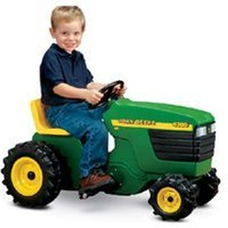
SLOVENIAN JOKE:
Janezek comes to school by himself and the teacher asks him:
-Janezek where is your sister?
-She was hit by a tractor.
-Where is your father?
-He was hit by a tractor
-And where is your mother?
-She was also hit by a tractor
-And where were you?
-I was driving the tractor

Crossword !!!
VERTICAL
1 Country that prepares evening today
2 Separating garbage
3 Recycling, making new things from old stuff
4 Paper, Metal, plastic, compost, ________
5 Bottle of water, a cup, plastic spon,...
6 Animals that live in our rooms during Eco beach
HORIZONTAL
1 Place for fish and other sea animals (where we keep them)
2 On Monday we were ______________ the beach
3 People use them every day , but they are not good for environment
4 School of turism and moritime _____________
5 ECO __________: a place where trash boxes are for all sorts of trash
6 Youth ____________

 | 1
1 |  |  |  |  | 2
 |  |  |  |  |  |  |  | 3 |  |  |  | 4
 |  |  |  | 2
 |  |  |  | 3
 |  |  |  |  |  |  |  |  | 5
 |  | 4
 |  |  |  |  |  |  |  |  |  |  |  | 6
 |  |  |  |  |  |  |  | 5
 |  |  |  |  |  | 6


Promoted by :  Financed by:
Supported by: 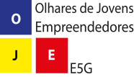
Writers:
Anja Jakse (Slovenia) | Natasa Kafkalia (Cyprus)
Javgenijs Mednis (Latvia) | Madis Latt (Estonia)
Nina Nahtigal (Slovenia) | João Cabreira (Portugal)

